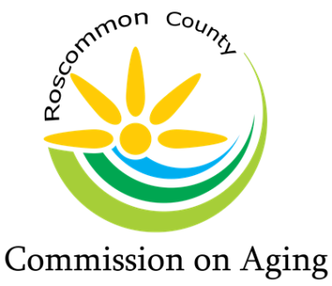
Mary T. Fry, Executive Director
1015 Short Dr Suite A, Prudenville, MI 48651
989.366.0205 Fax: 989.366.0136
www.rccoa.net

AGENDA
BOARD OF DIRECTORS MEETING
February 16, 2022

*** Please bring your Board Books to this meeting. We will collect them and update them with new materials and Standards. Thank You! ***

Pledge of Allegiance

Roll Call: Tracy Constance – Chair, Roberta Kary – Vice Chair, Madeline Hiller – Secretary, Al Schultz - Treasurer, Kim Warner, Chuck Corwin, Marc Milburn, Peggy Poynter, & Patty Bone

Mary Fry – Executive Director

Excused Absence:

Intro of Guest: David Husak – Future Energy Solutions

Reading of Mission Statement

The purpose of the Roscommon County Commission on Aging is to promote
the welfare, independence, safety, and health of our senior citizens through various programs

Approval of Agenda:

Approval of Consent Agenda:
Minutes from January 19, 2022, Board Meeting
In Home Service Report
Financial Report
Serenity Day Lodge Report
Director’s Team Report

Public Comment (please limit your comments to Agenda items & not more than 3 minutes)

Presentation: David Husak – Future Energy Solutions

Director’s Team Report:

By-Laws Committee Report - Roberta Kary:

Review and Approve 2021-2022 Budget:

Review/Discussion/Approve:
Updated Employee Handbook

Review and Discussion:
Future Energy Solutions Proposal
Consumer’s Energy Update

County Commissioner’s Report:

Region 9 Advisory Committee Report:

Bank Signature Cards:
- Motion to approve Executive Committee as Bank Card Signers.
(Signatures required from Executive Committee – Signature Cards)

Old Business:

New Business:

Public Comment: (please limit your comments to not more than 3 minutes)

Board Comments:

Adjournment:

