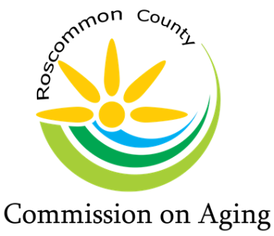
Mary T. Fry, Executive Director
1015 Short Dr Suite A, Prudenville, MI 48651
989.366.0205 Fax: 989.366.0136
www.rccoa.net

AGENDA
BOARD OF DIRECTORS MEETING
March 16, 2022

Pledge of Allegiance

Roll Call: Tracy Constance – Chair, Roberta Kary – Vice Chair, Madeline Hiller – Secretary, Al Schultz - Treasurer, Kim Warner, Chuck Corwin, Marc Milburn, Peggy Poynter, & Patty Bone

Mary Fry – Executive Director

Excused Absence:

Intro of Guest: Ron Obey – RCCOA Maintenance/Chores Coordinator

Reading of Mission Statement

The purpose of the Roscommon County Commission on Aging is to promote
the welfare, independence, safety, and health of our senior citizens through various programs

Approval of Agenda:

Approval of Consent Agenda:
Minutes from February 16, 2022, Board Meeting
In Home Service Report
Financial Report
Serenity Day Lodge Report
Resources Report
Director’s Team Report

Public Comment (please limit your comments to Agenda items & not more than 3 minutes)

Director’s Team Report:
Millage Renewal – Approval of Millage Renewal Request as written
Health Insurance – Employees
IHS Coordinator Resignation

Discussion / Approval of proposed By-Laws, as presented by the By-Laws Committee

Review Consumer’s Energy Proposal: (LED Lighting)

Presentation: Mary Fry – RCCOA Maintenance/Chores Coordinator – In-House LED Lighting estimated cost quote

Review and Discussion (LED Lighting):
Future Energy Solutions Proposal
Consumer’s Energy Proposal
In-House Proposal

County Commissioner’s Report:

Region 9 Advisory Committee Report:

Senior Center’s Report:
  - Houghton Lake Center Representatives: Tracy/Madeline
  - Roscommon Center Representatives: Kim/Peggy
  - St. Helen Center Representatives: Roberta/Patty

Old Business:

New Business:

Public Comment: (please limit your comments to not more than 3 minutes)

Board Comments:

Adjournment:

