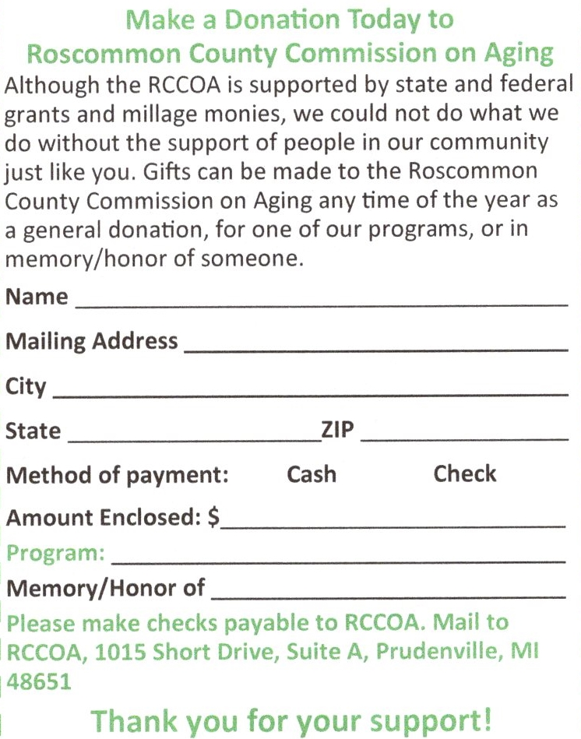

*If you would like to make a donation via credit/debit card please contact
Deb Looney at (989) 366-0205 Ext. #1103

