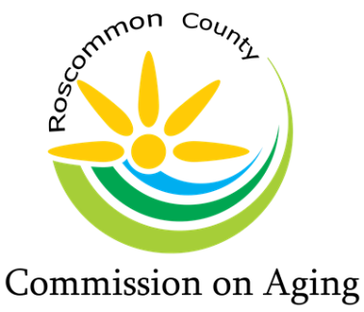
Mary T. Fry, Executive Director
1015 Short Dr Suite A, Prudenville, MI 48651
989.366.0205 Fax: 989.366.0136
www.rccoa.net

AGENDA
SPECIAL BOARD OF DIRECTORS MEETING
November 4, 2022, at 1:00pm

Special Board Meeting will be held at the Annex in the Administration Building
1015 Short Drive, Prudenville, 48651

Call Meeting to Order: Tracy Ellerbrock-Constance – Chair

Pledge of Allegiance

Roll Call: Tracy Ellerbrock-Constance – Chair, Madeline Hiller – Secretary, Al Schultz - Treasurer, Roberta Kary – Vice Chair, Chuck Corwin, Kim Warner, Patty Bone, Peggy Poynter, and Marc Milburn

Mary Fry – Executive Director

Excused Absence:

Intro of Guest:

Reading of Mission Statement: Mary Fry

The purpose of the Roscommon County Commission on Aging is to promote
the welfare, independence, safety, and health of our senior citizens through various programs

Approval of Agenda:

Public Comment: (please limit your comments to not more than 3 minutes)

Personnel Committee – Executive Director Annual Evaluation:

Approval of Revised Employee Handbook:

Financial Committee Report – 2022-2023 Budget:

Approval of Proposed 2022 – 2023 Fiscal Year Budget:

Old Business:

New Business:

Public Comment: (please limit your comments to not more than 3 minutes)

Board Comments:

Adjournment:

