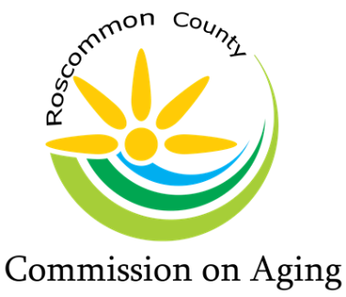
Mary T. Fry, Executive Director
1015 Short Dr Suite A, Prudenville, MI 48651
989.366.0205 Fax: 989.366.0136
www.rccoa.net

DRAFT AGENDA
BOARD OF DIRECTORS MEETING
February 15, 2023

Pledge of Allegiance:

Roll Call: Roberta Kary – Acting Chair, Peggy Poynter, Patty Bone, Kim Warner, Steve Perialas, Phyllis Piotroski, Kimberly Daniels, Marc Milburn, and Chuck Corwin

Executive Director, Mary T. Fry

Introduction of new Board members: Roberta Kary

Reading of Mission Statement: Mary T. Fry

The purpose of the Roscommon County Commission on Aging is to promote
the welfare, independence, safety, and health of our senior citizens through various programs

Approval of Agenda:

Motion: Second: Approval:

Intro of Guest:

Approval of Consent Agenda:
- Minutes – Board Meeting, January 18, 2023
- Day Lodge Report
- In Home Service Report
- Food Service/MOW’s Report
- Financial Reports
- Director’s Report

Motion: Second: Approval:

Public Comment: (please limit your comments to not more than 3 minutes)

Nominating Committee: Chuck Corwin

Recommendations for Executive Board Member:

Chairman:
Vice Chairman:
Treasurer:
Secretary:

Motion to Approve: Second: Roll Call:

Director’s Report: Mary Fry

Controller Report: Tracy Baker
- Balance Sheet – January 2023

County Commissioner’s Report: Marc Milburn

Region 9 Advisory Committee Report: Chuck Corwin

Old Business:

New Business:

Public Comment: (please limit your comments to not more than 3 minutes)

Board Comment:

Adjournment:

Motion: Second: Approval:

