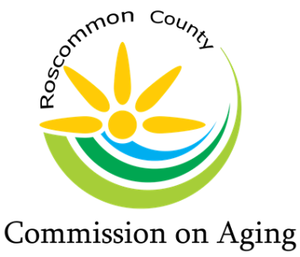
Mary T. Fry, Executive Director
1015 Short Dr Suite A, Prudenville, MI 48651
989.366.0205 Fax: 989.366.0136
www.rccoa.net

DRAFT AGENDA
BOARD OF DIRECTORS MEETING
June 21, 2023 – 1:00 pm

The June Board Meeting will be held at the
Houghton Lake Center
2625 S. Townline Road
Houghton Lake, MI 48629

Meeting Called to Order:

Pledge of Allegiance:

Roll Call: Roberta Kary – Chair, Peggy Poynter – Vice-Chair, Kim Warner - Treasurer, Steve Perialas, and Phyllis Piotrowski

Excused Absence: Chuck Corwin – Secretary, Patty Bone, Marc Milburn & Kimberly Daniels

Executive Director, Mary T. Fry

Intro of Guest:
Mark Miller, Business Relationship Manager - Chase Bank
Margie Crompton, Customer Service Representative – Mercantile Bank
Scott Leesch, VP, Senior Government Relationship Manager – Huntington Bank
Katlyn Franks – Financial Analyst, Region 9 AAA

Reading of Mission Statement: Mary T. Fry

The purpose of the Roscommon County Commission on Aging is to promote
the welfare, independence, safety, and health of our senior citizens through various programs

Approval of Agenda:

Motion: Second: Approval:

Approval of Consent Agenda:
- Minutes – Board Meeting, May 10, 2023
- Day Lodge Report
- In Home Service Report
- Food Service/MOW’s Report
- Financial Reports
- Director’s Report

Motion: Second: Approval:

Public Comment: (please limit your comments to not more than 3 minutes)

Bank Presentations: (Each Bank submitted a packet for Board review that was included in the Board Meeting Packet.)
(To ensure that there was no perceived prejudice, Mary Fry put each institution’s name into a bowl and Tracy Baker drew the names in the order that they are represented for presentation.)

Huntington Bank Presentation: Scott Leesch, Vice President – Sr. Government Relationship Manager

Chase Bank Presentation: Mark Miller, Business Relationship Manager

Mercantile Bank Presentation: Margie Crompton, Customer Service Representative

Board Q & A with Bank representatives:

Director’s Report: Mary Fry
- Signature Card completion for Huntington Bank

Controller Report: Mary Fry

Senior Center Reports:

Houghton Lake: (Phyllis Piotrowski)

Roscommon: (Peggy Poynter & Kim Warner)

St. Helen: (Roberta Kary)

County Commissioner’s Report: Marc Milburn will give report at July meeting

Region 9 Advisory Committee Report: Meetings will be reported at the July Board Meeting

Old Business:

New Business:

Veteran’s Coffee Hour:
Does the RCCOA want to take responsibility for The Veteran’s Coffee Hour, the first Thursday of each month at Blodgett/Roscommon Airport?

Motion: Second: Approval:

Public Comment: (please limit your comments to not more than 3 minutes)

Board Comment:

Adjournment:

Motion: Second: Approval:

